PAR EFFICIENCY
Simple & Complex Contingency Orders
Test Plan

Wege Kifle

Table of Contents

Test Setup Instructions: 5
COMPLEX CONTINGENCY ORDERS: 6
PAR_TRADE_ALL (T/A): AON, FOK, IOC 6
Test Case 1.Complex Order With the following Contingency Type is rejected when Strategy product state is ON_HOLD. 6
Test Case 2.Complex I-Order With the following Contingency Type is rejected 6
Test Case 3.Complex AON order trades against Leg Quotes. Remaining order qty is routed back to PAR 7
Test Case 4.Complex AON order trades against Spread quote & Leg Quotes. No remaining qty. 7
Test Case 5.Complex AON order with price within legal market range but not tradable with spread order is routed back to PAR 7
Test Case 6.Complex AON order with price below legal market range trades with Leg quotes. The remaining qty is routed back to PAR. 8
Test Case 7.Complex AON order with price above legal market range; Order is routed back to PAR 8
Test Case8. incoming Complex AON order is rejected when there is an active Quote Trigger on the Legs, spread product is ON-HOLD 8
Test Case9. incoming Complex AON order doesn’t force QT to expire on the Leg. Order trades with leg quotes. No remaining AON order qty. 9
Test Case 10. Same Priced incoming Complex AON order within the Derived Quote forces spread QT to expire. Order is routed back to PAR 9
PAR_TRADE_ALL (T/A): MIN 10
Test Case 11.Complex MIN order trades against spread order and leg quotes. No remaining qty. 10
Test Case12. incoming Complex MIN order doesn’t force QT to expire on the Leg. Order trades with leg quotes. No remaining MIN order qty. 10
Test Case 13. Worst Priced incoming Complex MIN order within the Derived Quote doesn’t force spread QT to expire. 11
Test Case 14.Verify that Complex STP order is rejected from SBT 11
AUCTION 11
Test Case 15.Verify that Auctions does not start for Complex Contingency Orders other than IOC 12
Test Case 16. Complex Auction IOC order trades against the resting Top Of Book spread quotes 12
Test Case 17.Joining Complex IOC Auction order and Original Auction order trade against the resting Top Of Book spread orders and legs; remaining IOC order is canceled 12
Test Case 18.Incoming Complex IOC order with instruction to be auctioned during Spread Quote Trigger. 13
Test Case19. Complex Auction IOC order does not trade against legs with there are 0(zero) bids. 13
Test Case 20.Cancel Auction Complex IOC order during active Auction; No RFPs received 14
SIMPLE CONTINGENCY ORDERS: 15
PAR_TRADE_ALL (T/A): (AON, FOK, IOC, & MOC) 15
Test Case 21. Incoming AON order trades with I-Order and resting quote. The remaining quantity is routed back to PAR. 15
Repeat the above Test Cases for FOK, IOC, and MOC Simple Contingency Orders 15
PAR_TRADE_ALL (T/A): (MIN) 15
Test Case 22.Incoming MIN order trades with I-Order and resting quote. The remaining quantity is routed back to PAR. 15
PAR_TRADE_ALL (T/A): (STP_LIMIT) : 16
Test Case 23. Incoming STP_LIMIT order starts HAL Auction (Tweener). 16
Test Case 24.Incoming STP_LIMIT order trades with I-Order and resting quote. The remaining quantity is routed back to PAR. 16
Test Case 25.Cancel/Replace STP_LIMIT order after HAL Auction Expires and while it is resting in PAR 16
PAR_TRADE_ALL (T/A): (STP): 17
Test Case 26.Incoming opposite side STP order during QT forces QT to expires and trades with remaining order; then starts HAL auction 17
PAR_TRADE_WITHBOOK (T/B): (AON, FOK, IOC & MOC) 17
Test Case 27.Incoming AON order trades partially with Customer Order. The remaining quantity is routed back to PAR. 17
PAR_TRADE WITHBOOK (T/B): (MIN) 18
Test Case 28.Incoming opposite side MIN order during QT trades with customer order. 18
PAR_TRADE_WITHBOOK (T/B): (STP_LIMIT) 18
Test Case 29. Incoming STP_LIMIT order dose not trade with I-Order 18
PAR_TRADE_WITHBOOK (T/B): (STP) 19
Test Case 30. Incoming STP order dose not trade with I-Order 19
Test Case 31.Cancel/Replace STP order after HAL Auction expired and while it is in PAR 19
BOOK: (AON) 19
Test Case 32.Incoming AON order trades with Customer LMT order, I-Order and resting quote. 20
BOOK: (FOK) 20
Test Case 33.Incoming FOK order trades with I-Order and resting quote. 20
BOOK: (IOC) 20
Test Case 34.Incoming IOC order trades with Customer and I order. 20
BOOK: (STP_LIMIT) 21
Test Case 35.Incoming STP_LIMIT order trades with I-Order and resting quote. The remaining quantity is Booked. 21
Test Case 36.Cancel/Replace STP_LIMIT order after HAL Auction expired and while it is in PAR 21
BOOK: (STP) 22
Test Case 37.Incoming STP order trades with I-Order and resting quote. The remaining quantity is re routed to book. 22
Test Case 38. Quote Lock starts during HAL Auction. HAL Auction expires immediately and STP order is re-routed to book 22
BOOK: (MOC) 23
Test Case 39.Incoming MOC order trades with I-Order and resting quote. The remaining quantity re routs to book; then MOC order trades with incoming customer order. 23
BOOK: (MIN) 23
Test Case 40. Incoming MIN order trades with Customer LMT order, resting quote & I-Order. 23
BOOK (with HAL Auction) 23
AON 24
Test Case 41.Incoming AON order starts a HAL Auction (Tweener). No incoming order or quote during auction. AON order is booked 24
Test Case 42.Order Cancel/Replace received for AON order during HAL Auction. 24
Test Case 43.Incoming AON order starts HAL Auction; RFP Response arrives during HAL Auction and starts a QT; Additional RFP Response arrives and joins QT; 24
IOC 25
Test Case 44.Incoming IOC order starts a HAL Auction (Tweener). No incoming order or quote during auction. IOC order is canceled 25
Test Case 45.Incoming IOC order starts a HAL Auction then trades immediately with incoming single customer order; the remaining ICO order is canceled after auction expires. 25
FOK 25
Test Case 46.Incoming FOK order starts a HAL Auction (Tweener). No incoming order or quote during auction. FOK order is canceled 25
Test Case 47.Incoming FOK order starts HAL Auction; RFP Response with less order volume arrives during HAL Auction. QT does not start; 26
MOC 26
Test Case 48.Incoming MOC order during HAL auction. MOC order trades with HAL order and resting quote immediately; the remaining MOC order is re-routed to book 26
MIN 26
Test Case 49.Incoming MIN order starts a HAL Auction then trades with Customer order 27
APPENDIX A: 28

Test Setup Instructions:

Trading Property Setup:

- Auction Enabled to TRUE for HAL (4) & COA(2)
- Auction Min Max Order Size to 1(lower limit) and 10000(upper limit) for HAL (4) & COA (2)
- Auction Min Number Of Quoters to 1 for HAL (4)
- Auction Min Price Increment to 1 for HAL (4)
- Auction Minimum Order Size For Ticks Above NBBO to 1 for HAL (4)
- Auction Order Ticks Away From NBBO to 1 for HAL (4)
- Auction Receiver Type to 1-ClassQuoter for HAL (4) & COA(2)
- Auction Time To Live to value that will be long enough to execute your test events before auction expires for HAL (4), & COA (2)
- Quote Lock Timer long enough to enter the required sequence of events
- Quote Trigger Timer long enough to enter the required sequence of events
- HAL Trigger Timer long enough to enter the required sequence of events
- MOC Interval Seconds to a time to trigger order immediately
- Make sure that Test product is on OpeningRotation state (unless specified in the individual test cases)
- Make sure that ALL MMs are subscribed for HAL (Auction type 4) & Strategy (Auction type 2)in order to enter RFPs.

PAR ORDER ROUTING SETUP

- Make sure The Order Routing Table on TPF is setup correctly for your class (See Appendix)

COMPLEX CONTINGENCY ORDERS:

- The following test cases use a Ratio of a 1:1 Strategy product with:
  - Leg Product 1: Buy 1
  - Leg Product 2: Sell 1

- Put the Leg products into Open Rotation State
- Put the Strategy product into Open State

PAR_TRADE_ALL (T/A): AON, FOK, IOC

Test Case 1Complex Order With the following Contingency Type is rejected when Strategy product state is ON_HOLD.

Enter the following from SBT

  - MM1 Enters Quote (Leg1 product): 1.00 – 1.20 100 x 100
  - MM1 Enters Quote (Leg2 product): 1.00 – 1.20 100 x 100

  - CUST1 Enters AON ‘C’ order: opposite 100@-0.30
Verify: AON order is routed to PAR
  - CUST1 Enters IOC ‘C’ order: opposite 100@-0.30
Verify: IOC order is routed to PAR
  - CUST1 Enters FOK ‘C’ order: opposite 100@-0.30
Verify: FOK order is routed to PAR
  - CUST1 Enters MIN ‘C’ order: opposite 100@-0.30
Verify: MIN order is routed to PAR
  - Cancel Both Quotes
  - Strategy product state should be ON_HOLD
  - Send ALL THE ABOVE orders from m PAR to SBT using T/A

Result
- All the above Orders are rejected since product state is NOT OPEN

Test Case 2Complex I-Order With the following Contingency Type is rejected

Enter the following from SBT

  - MM1 Enters Quote (Leg1 product): 1.00 – 1.20 100 x 100
- MM1 Enters Quote (Leg2 product): 1.00 – 1.20 100 x 100

  - CUST1 Enters AON ‘I’ order: opposite 100@-0.30
  - CUST2 Enters IOC ‘I’ order: opposite 100@-0.30
  - CUST3 Enters FOK ‘I’ order: opposite 100@-0.30
  - CUST4 Enters MIN ‘I’ order: opposite 100@-0.30

Result
- Quote Like Order with Contingency is not accepted

Test Case 3Complex AON order trades against Leg Quotes. Remaining order qty is routed back to PAR

Enter the following from SBT

  - MM1 Enters Quote (Leg1 product): 1.00 – 1.20 100 x 100
- MM1 Enters Quote (Leg2 product): 1.00 – 1.20 100 x 100
  - CUST1 Enters AON ‘C’ order: opposite 150@-0.30
Verify: AON order is routed to PAR
- Send AON order from PAR to SBT using T/A

Result:
- AON order trades with leg quotes
- Spread AON Order fills 100@-0.20
- Leg1 Quote fills Sell 100@1.20
- Leg2 Quote fills Buy100@1.00
- Remaining spread 50 AON order qty is routed back to PAR

Test Case 4Complex AON order trades against Spread quote & Leg Quotes. No remaining qty.

Enter the following from SBT

  - MM1 Enters Quote (Leg1 product): 1.00 – 1.20 100 x 100
- MM1 Enters Quote (Leg2 product): 1.00 – 1.20 100 x 100
- MM2 Enters Spread Quote: -0.10 – 0.20 50x50
- CUST1 Enters AON ‘C’ order: opposite 100@-0.30
Verify: AON order is routed to PAR
- Send AON order from PAR to SBT using T/A

Result:
- AON order trades with spread quote
- AON order fills 50@0.10
- Spread Quote fills 50@-0.10
- AON order trades with Leg Quotes
- AON order Fills 50@ -0.20
- Leg1 Quote fills Sell 50@1.20
- Leg2 Quote fills Buy 50@1.00

Test Case 5Complex AON order with price within legal market range but not tradable with spread order is routed back to PAR

Enter the following from SBT

  - MM1 Enters Quote (Leg1 product): 1.00 – 1.20 100 x 100
- MM1 Enters Quote (Leg2 product): 1.00 – 1.20 100 x 100
- CUST1 Enters ‘M’ order: Same 100@0.10
- CUST2 Enters AON ‘C’ order: opposite 100@-0.15
Verify: AON order is routed to PAR
- Send AON order from PAR to SBT using T/A

Result:
- AON spread order is routed back to PAR

Test Case 6Complex AON order with price below legal market range trades with Leg quotes. The remaining qty is routed back to PAR.

Enter the following from SBT

  - MM1 Enters Quote (Leg1 product): 1.00 – 1.20 100 x 100
- MM1 Enters Quote (Leg2 product): 1.00 – 1.20 100 x 100
- CUST1 Enters AON ‘C’ order: opposite 100@-0.50
Verify: AON order is routed to PAR
- Send AON order from PAR to SBT using T/A

Result:
- AON order trades with Leg Quotes
- AON Order fills 100@-0.20
- Leg1 Quote fills Sell 100@1.20
- Leg2 Quote fills Buy 100@1.20
- The remaining 100 AON order qty is routed back to PAR

Test Case 7Complex AON order with price above legal market range; Order is routed back to PAR

Enter the following from SBT

  - MM1 Enters Quote (Leg1 product): 1.00 – 1.20 100 x 100
- MM1 Enters Quote (Leg2 product): 1.00 – 1.20 100 x 100
- CUST1 Enters AON ‘C’ order: Same 100@0.30
Verify: AON order is routed to PAR
- Send AON order from PAR to SBT using T/A

Result:
- AON Order is routed back to PAR

Test Case8 incoming Complex AON order is rejected when there is an active Quote Trigger on the Legs, spread product is ON-HOLD

Enter the following from SBT

  - CUST1 Enters ‘M’ Order (Leg1 product): Buy 100@1.20
- MM1 Enters Quote (Leg2 product): 1.00 – 1.20 100 x 100
  - MM1 Enters Quote (Leg1 product): 1.00 – 1.20 100 x 100
  - QT Starts on the leg 100@1.20
- CUST2 Enters AON ‘C’ order: Opposite 100@-0.40
Verify: AON order is routed to PAR
- Send AON order from PAR to SBT using T/A

Result:
- AON Order is routed back to PAR
- CUST1’s order trades with quote 100@1.20 after QT expires
- Leg1 Quote Fill Sell 100@1.20
- CUST1’s order Fills 100@1.20

Test Case9 incoming Complex AON order doesn’t force QT to expire on the Leg. Order trades with leg quotes. No remaining AON order qty.

Enter the following from SBT

  - CSUT1 Enters ‘M’ Enters Order (Leg1 product): Buy 100@1.20
- MM1 Enters Quote (Leg2 product): 1.00 – 1.20 200 x 200
  - MM1 Enters Quote (Leg1 product): 1.00 – 1.20 200 x 200
  - QT Starts on the leg 100@1.20
- CUST2 Enters AON ‘C’ order: Opposite 50@-0.30
Verify: AON order is routed to PAR
- Send AON order from PAR to SBT using T/A

Result:
- AON Order trades immediately with Leg quotes
- AON order fills 50@-0.20
- Leg1 Quote fills Buy 50@1.20
- Leg2 Quote fills Sell 50@1.00
- Quote Trigger Continues on Legs
- CUST1’s order trades with quote 100@1.20 after QT expires
- Leg1 Quote Fill Sell 100@1.20
- CUST1’s order Fills 100@1.20

Test Case 10 Same Priced incoming Complex AON order within the Derived Quote forces spread QT to expire. Order is routed back to PAR

Enter the following from SBT

  - MM1 Enters Quote (Leg1 product): 1.00 – 1.20 100 x 100
- MM1 Enters Quote (Leg2 product): 1.00 – 1.20 100 x 100
- CUST1 Enters Complex ‘M’ Order: Same 70@0.15
- MM1 Enters Complex ‘I’ Order: Opposite 70@-0.15
  - Spread QT Starts 70@0.15
- CUST3 Enters AON ‘C’ order: Same 70@0.15
Verify: AON order is routed to PAR
- Send AON order from PAR to SBT using T/A

Result:
- Spread Quote Trigger expires immediately
- CUST1 order trades with CUST2 order
- AON order is routed back to PAR
- CUST1 order fills defined 70@0.15
- MM1 order fills opposite 70@-0.15

PAR_TRADE_ALL (T/A): MIN

Test Case 11Complex MIN order trades against spread order and leg quotes. No remaining qty.

Enter the following from SBT

  - MM1 Enters Quote (Leg1 product): 1.00 – 1.20 100 x 100
- MM1 Enters Quote (Leg2 product): 1.00 – 1.20 100 x 100
- CUST1 Enters ‘M’ order: Same 50@0.10
- CUST2 Enters MIN ‘C’ order: opposite 100(50)@-0.30
Verify: MIN order is routed to PAR
- Send MIN order from PAR to SBT using T/A

Result:
- MIN order trades with CUST1 order
- MIN order fills 50@-0.10
- Spread Order fills 50@0.10
- MIN order trades with Leg Quotes
- MIN Order fills 50@-0.20
- Leg1 Quote fills Sell 50@1.20
- Leg2 Quote fills Buy 50@1.00

Test Case12 incoming Complex MIN order doesn’t force QT to expire on the Leg. Order trades with leg quotes. No remaining MIN order qty.

Enter the following from SBT

  - CUST1 Enters ‘M’ Enters Order (Leg1 product): Buy 100@1.20
- MM1 Enters Quote (Leg2 product): 1.00 – 1.20 200 x 200
  - MM1 Enters Quote (Leg1 product): 1.00 – 1.20 200 x 200
  - QT Starts on the leg 100@1.20
- CUST2 Enters MIN ‘C’ order: Opposite 50(10)@-0.30
Verify: MIN order is routed to PAR
- Send MIN order from PAR to SBT using T/A

Result:
- MIN Order trades immediately with Leg quotes
- MIN order fills 50@-0.20
- Leg1 Quote fills Buy 50@1.20
- Leg2 Quote fills Sell 50@1.00
- Quote Trigger Continues on Legs
- Simple Customer order trades with quote 100@1.20 after QT expires
- Leg1 Quote Fill Sell 100@1.20
- CUST1 order Fills 100@1.20

Test Case 13 Worst Priced incoming Complex MIN order within the Derived Quote doesn’t force spread QT to expire.

Enter the following from SBT

  - MM1 Enters Quote (Leg1 product): 1.00 – 1.20 100 x 100
- MM1 Enters Quote (Leg2 product): 1.00 – 1.20 100 x 100
- CUST1 Enters Complex ‘M’ Order: Same 70@0.15
- CUST2 Enters Complex ‘I’ Order: Opposite 70@-0.15
  - Spread QT Starts 70@0.15
- CUST3 Enters MIN ‘C’ order: Same 70(50)@0.20
Verify: MIN order is routed to PAR
- Send MIN order from PAR to SBT using T/A

Result:
- Spread Quote Trigger does not expire immediately
- MIN order is routed back to PAR
- CUST1 order trades with CUST2 order after QT expires
- CUST1 order fills defined 70@0.15
- CUST2 order fills opposite 70@-0.15

Test Case 14Verify that Complex STP order is rejected from SBT

Enter the following from SBT

  - MM1 Enters Quote (Leg1 product): 1.00 – 1.20 100 x 100
- MM1 Enters Quote (Leg2 product): 1.00 – 1.20 100 x 100
- MM2 Enters Complex STP ‘I’ Order: Same 70@MKT (STP Price = 1.00)

Result:
- Error Message “Quote like order is not accepted “should be displayed on the GUI.

AUCTION

- The following Test Cases use ‘F’ origin for Auction order

Test Case 15Verify that Auctions does not start for Complex Contingency Orders other than IOC

Enter the following from SBT

  - MM1 Enters Quote (Leg1 product): 1.00 – 1.20 100 x 100
- MM1 Enters Quote (Leg2 product): 1.00 – 1.20 100 x 100
- CUST1 Enters Complex AON ‘F’ Order: opposite 70@-0.30
Verify: AON order is routed to PAR
  - Send AON order from PAR to SBT using AUCTION

Result:
- Order does not route back to SBT. You should see Contingency Type is Invalid on TPF message

Repeat the above test case for AON, FOK and MIN Complex Contingency Orders

Test Case 16 Complex Auction IOC order trades against the resting Top Of Book spread quotes

Enter the following from SBT

  - MM1 Enters Quote (Leg1 product): 1.00 – 1.20 100 x 100
  - MM1 Enters Quote (Leg2 product): 1.00 – 1.20 100 x 100
  - MM2 enters a spread quote:
  - Same side: 0.20x10 Opposite side: 0.10x10
- MM3 enters a spread quote:
  - Same side: 0.20x10 Opposite side: 0.05x10
  - CUST1 Enters IOC ‘F’ order: Same 100@0.10(debit)
Verify: IOC order is routed to PAR
  - Send IOC order from PAR to SBT using AUCTION
  - Auction Starts

Result:
- After timer ends, IOC order trades against the Top Of Book opposite side quotes at 10@0.05 and 10@0.10
- The remaining 80 IOC order is canceled

Test Case 17Joining Complex IOC Auction order and Original Auction order trade against the resting Top Of Book spread orders and legs; remaining IOC order is canceled

Enter the following from SBT

  - MM1 Enters Quote (Leg1 product): 1.00 – 1.20 100 x 100
  - MM1 Enters Quote (Leg2 product): 1.00 – 1.20 100 x 100
  - CUST1 Enters ‘C’ Spread Order: Opposite 20@0.10 (credit)
  - CUST2 Enters ‘C’ Spread Order: Opposite 20@0.05 (credit)
  - CUST3 Enters IOC ‘F’ order: Same 100@0.25 (debit)
Verify: IOC order is routed to PAR
  - Send IOC order from PAR to SBT using AUCTION
  - Auction Starts
  - CUST4 Enters IOC ‘F’ order: Same 100@0.25 (debit)
  - Send CUST4 order from PAR to SBT using AUCTION ,CUST4 joins the Auction

Result:
- After Auction timer ends, CUST3 IOC order trades against the Top Of Book opposite side orders 20@0.10 and 20@0.05, then against the legs 60@0.20
- CUST4 IOC joining order trades against the remaining part of the Leg quote for 40@ -0.20
- The remaining CUST4 order is canceled

Test Case 18Incoming Complex IOC order with instruction to be auctioned during Spread Quote Trigger.

Enter the following from SBT

- MM1 Enters Quote (Leg1 product): 1.00 – 1.20 100 x 100
- MM1 Enters Quote (Leg2 product): 1.00 – 1.20 100 x 100
- CUST1 Enters ‘C’ Spread order: Same 100@0.10 (debit)
- MM2 Enters ‘I’ Spread Order: opposite 200@0.05 (debit)

- CUST2 Enters IOC ‘F’ order: Same 100@0.05 (debit)
Verify: IOC order is routed to PAR
- Send IOC order from PAR to SBT using AUCTION

Result:

- MM2 order trades against CUST1 order 100@0.10 credit; Remaining MM2 100 qty is booked
- IOC order starts an Auction
- After Auction timer ends, IOC order trades against the resting MM2 order 100@0.05

Test Case19 Complex Auction IOC order does not trade against legs with there are 0(zero) bids.

Enter the following from SBT

  - MM1 Enters Quote (Leg1 product): 1.00 x 100 - 1.20 x 100
  - MM1 Enters Quote (Leg2 product): 1.00 x 100 - 1.20 x 100
  - CUST1 Enters IOC ‘F’ order: Same 100@0.20(debit)
Verify: IOC order is routed to PAR
  - Send IOC order from PAR to SBT using AUCTION
  - Auction Starts
  - MM1 Enters Quote (Leg1 product): 0.00 x 0 - 1.20 x 100
  - MM1 Enters Quote (Leg2 product): 0.00 x 0 - 1.20 x 100

Result:
- After Auction timer Expires, IOC Auction order is canceled

Test Case 20Cancel Auction Complex IOC order during active Auction; No RFPs received

Enter the following from SBT

  - MM1 Enters Quote (Leg1 product): 1.00 – 1.20 100 x 100
  - MM1 Enters Quote (Leg2 product): 1.00 – 1.20 100 x 100
  - CUST1 Enters IOC ‘F’ order: Same 100@0.20 (debit)
Verify: IOC order is routed to PAR
  - Send IOC order from PAR to SBT using AUCTION
  - Auction Starts
- Cancel IOC order; Request is pending
Result:
  - After Auction expires, IOC order trades with leg quotes.

SIMPLE CONTINGENCY ORDERS:

PAR_TRADE_ALL (T/A): (AON, FOK, IOC, & MOC)

Test Case 21 Incoming AON order trades with I-Order and resting quote. The remaining quantity is routed back to PAR.

Enter the following from SBT

- MM1 Enter Quote: 1.00 – 1.30 100 x 100
- MM1 Enter ‘I’ order: Sell 100@1.30
- CUST1 Enter AON ‘C’ Order: Buy 300@1.40
Verify: AON order is routed to PAR
- CUST2 Enter Order: Sell 300@1.40
- Send AON order from PAR to SBT using T/A

Result:
- AON order trades with MM1’s I Order 100@1.30
- AON order trades with MM1’s quote 100@1.30
- The remaining 100 AON order is routed back to PAR

Repeat the above Test Cases for FOK, IOC, and MOC Simple Contingency Orders

PAR_TRADE_ALL (T/A): (MIN)

Test Case 22Incoming MIN order trades with I-Order and resting quote. The remaining quantity is routed back to PAR.

Enter the following from SBT

- MM1 Enter Quote: 1.00 – 1.30 100 x 100
- MM1 Enter ‘I’ order: Sell 100@1.30
- CUST1 Enter MIN ‘C’ Order: Buy 300(200)@1.40
Verify: MIN order is routed to PAR
- CUST2 Enter Order: Sell 300@1.40
- Send MIN order from PAR to SBT using T/A

Result:
- MIN order trades with MM1’s I Order 100@1.30
- MIN order trades with MM1’s quote 100@1.30
- The remaining 100 MIN order is routed back to PAR

PAR_TRADE_ALL (T/A): (STP_LIMIT) :

To Route STP_LIMIT Order from SBT to PAR, STP_Limit order must be triggered and HAL’d First with NBBOReject.
- The following Test Cases use: NBBO: 1.00 – 1.15 100 x 100
- The following Test Cases use ‘D’ origin for HAL order

Test Case 23 Incoming STP_LIMIT order starts HAL Auction (Tweener).

Enter the following from SBT

- MM1 Enters Quote: 1.00 – 1.20 100 x 100
- CUST1 Enters STP_LIMIT ‘D’ order: Buy 100 @1.10 (STP_LIMIT price = 1.00)
  - HAL Auction starts: 100 @ 1.10
  - After HAL auction Expired, Verify that STP_LIMIT order is NOT routed to PAR (Order cannot go to PAR since it is not NBBOReject)
Result:
- STP_LIMIT order is booked

Test Case 24Incoming STP_LIMIT order trades with I-Order and resting quote. The remaining quantity is routed back to PAR.

Enter the following from SBT

- MM1 Enter Quote: 1.00 – 1.20 100 x 100
- MM1 Enter ‘I’ order: Sell 100@1.20
- CUST1 Enter STP_LIMIT ‘D’ Order: Buy 300@1.30 (STP_LIMIT price=1.00)
  - HAL Auction starts: 300 @ 1.15
Verify: STP_LIMIT order is routed to PAR after HAL auction expires
- Send STP_LIMIT order from PAR to SBT using T/A

Result:
- STP_LIMIT order trades with MM1’s I Order 100@1.20
- STP_LIMIT order trades with MM1’s quote 100@1.20
- The remaining 100 STP_LIMIT order is routed back to PAR

Test Case 25Cancel/Replace STP_LIMIT order after HAL Auction Expires and while it is resting in PAR

Enter the following from SBT

- MM1 Enter Quote: 1.00 – 1.20 100 x 100
- CUST1 Enter STP_LIMIT ‘D’ Order: Buy 150@1.20 (STP_LIMIT price=1.00)
  - HAL Auction starts: 150 @ 1.15
Verify: STP_LIMIT order is routed to PAR after HAL Auction expires

- Cancel/Replace STP_LIMIT ‘D’ Order: Buy 100@1.20 (STP_LIMIT price=1.00)

  - Verify that 150 STP order is canceled immediately (Trader GUI)
Verify: The New STP_LIMIT 100 order is routed to PAR

- MM1 re-Quote: 0.90 – 1.20 100 x 100
- Send STP_LIMIT order from PAR to SBT using T/A

Result:
- STP_LIMIT order trades with MM1’s Quote for 100@1.20

PAR_TRADE_ALL (T/A): (STP):

To Route STP Order from SBT to PAR, STP order must be triggered and HAL’d First with NBBOReject.
- The following Test Cases use: NBBO: 1.00 – 1.15 100 x 100
- The following Test Cases use ‘D’ origin for HAL order

Test Case 26Incoming opposite side STP order during QT forces QT to expires and trades with remaining order; then starts HAL auction

Enter the following from SBT

- MM1 Enter Quote: 1.00 – 1.20 100 x 100
- CUST1 Enters ‘M’ order: Buy 10@1.10
- CUST2 Enters ‘I’ order: Sell 30@1.10
  - Quote Trigger starts: 10@1.10
- CUST3 Enter STP ‘D’ Order: Buy 100@MKT (STP price=1.00)
  - QT expires immediately and CUST1 order Trades with CUST2 order for 10@1.10
  - STP order trades with CUST2 ‘I’ order for 20@1.10
  - HAL Auction starts for the remaining 80 order qty 80 @ 1.15
Verify: STP order is routed to PAR, after HAL auction expires
- Send STP order from PAR to SBT using T/A

Result:
- STP order trades with MM1 quote for 80@1.20

PAR_TRADE_WITHBOOK (T/B): (AON, FOK, IOC & MOC)

Test Case 27Incoming AON order trades partially with Customer Order. The remaining quantity is routed back to PAR.

- MM1 Enter Quote: 1.00 – 1.30 100 x 100
- CUST1 Enter ‘M’ Order: Buy 100@1.00
- CUST2 Enter AON ‘C’ Order: Sell 150@1.00
Verify: AON order is routed to PAR
- Send AON order from PAR to SBT using T/B

Result:
- AON order trades with CUST1 order 100@1.00
- The remaining 50 AON order is routed back to PAR

PAR_TRADE WITHBOOK (T/B): (MIN)

Test Case 28Incoming opposite side MIN order during QT trades with customer order.

Enter the following from SBT

- MM1 Enter Quote: 1.00 – 1.20 100 x 100
- CUST1 Enters ‘M’ order: Sell 200@1.10
- MM1 re-quote: 1.10 – 1.20 100 x 100
  - Quote Trigger starts: 100@1.10
- CUST2 Enter MIN ‘C’ Order: Buy 100(90)@1.10
Verify: MIN order is routed to PAR
- Send MIN order from PAR to SBT using T/B

Result:
- QT is not interrupted
- MIN order trades with CUST1 order for 100@1.10
- After QT expires, CUST1 order trades with MM1’s Quote for 100@1.10

PAR_TRADE_WITHBOOK (T/B): (STP_LIMIT)

To Route STP_LIMIT Order from SBT to PAR, Order must be triggered and HAL’d First with NBBOReject.
- The following Test Cases use: NBBO: 1.00 – 1.15 100 x 100
- The following Test Cases use ‘D’ origin for HAL order

Test Case 29 Incoming STP_LIMIT order dose not trade with I-Order

Enter the following from SBT

- MM1 Enter Quote: 1.00 – 1.20 100 x 100
- CUST1 Enter STP_LIMIT ‘D’ Order: Buy 100@1.20 (STP_LIMIT price=1.00)
  - HAL Auction starts: 100 @ 1.15
Verify: STP_LIMIT order is routed to PAR after HAL Auction expires,
- CUST2 Enter ‘I’ order: Sell 100@1.05
- Send STP_LIMIT order from PAR to SBT using T/B

Result:
- STP_LIMIT order is routed back to PAR.

PAR_TRADE_WITHBOOK (T/B): (STP)

To Route STP Order from SBT to PAR, Order must be triggered and HAL’d First with NBBOReject.
- The following Test Cases use: NBBO: 1.00 – 1.15 100 x 100
- The following Test Cases use ‘D’ origin for HAL order

Test Case 30 Incoming STP order dose not trade with I-Order

Enter the following from SBT

- MM1 Enter Quote: 1.00 – 1.20 100 x 100
- CUST1 Enter STP ‘D’ Order: Buy 100@MKT (STP price=1.00)
  - HAL Auction starts: 100 @ 1.15
Verify: STP order is routed to PAR after HAL Auction expires,
- CUST2 Enter ‘I’ order: Sell 100@1.05
- Send STP order from PAR to SBT using T/B

Result:
- STP order is routed back to PAR.

Test Case 31Cancel/Replace STP order after HAL Auction expired and while it is in PAR

Enter the following from SBT
- NBBO : 0.90 – 1.15 100 x 100
- MM1 Enter Quote: 1.00 – 1.20 100 x 100
- CUST1 Enter STP ‘D’ Order: Buy 150@MKT (STP price=1.00)
  - HAL Auction starts: 150 @ 1.15
Verify: STP order is routed to PAR after HAL Auction expires
- Cancel/Replace STP ‘D’ Order: 100@MKT (STP price=1.00)
  - Verify that the 150 STP order is canceled immediately (Trader GUI)
Verify: The new STP 100 order is routed to PAR
- MM1 re-Quote: 0.90 – 1.20 100 x 100
- CUST2 Enter ‘M’ order: Sell 50@1.00
- Send STP order from PAR to SBT using T/B

Result:
- STP order trades with CUST2 order for 50@1.00
- The remaining 50 STP order is routed back to PAR

BOOK: (AON)

Test Case 32Incoming AON order trades with Customer LMT order, I-Order and resting quote.

Enter the following from SBT

- MM1 Enter Quote: 1.00 – 1.30 100 x 100
- MM1 Enter ‘I’ order: Sell 50@1.30
- CUST1 Enter AON ‘C’ Order: Buy 200@1.40
Verify: AON order is routed to PAR
- CUST2 Enter Order: Sell 50@1.30
- Send AON order from PAR to SBT using BOOK

Result:
- AON order trades with MM1’s I Order 50@1.30
- AON order trades with CUST2’s Order 50@1.30
- AON order trades with MM1’s quote 100@1.30

BOOK: (FOK)

Test Case 33Incoming FOK order trades with I-Order and resting quote.

Enter the following from SBT

- MM1 Enter Quote: 1.00 – 1.30 100 x 100
- MM1 Enter ‘I’ order: Sell 100@1.30
- CUST1 Enter FOK ‘C’ Order: Buy 200@1.40
Verify: FOK order is routed to PAR
- Send FOK order from PAR to SBT using BOOK

Result:
- FOK order trades with MM1’s I Order 100@1.30
- FOK order trades with MM1’s quote 100@1.30

BOOK: (IOC)

Test Case 34Incoming IOC order trades with Customer and I order.

Enter the following from SBT

- MM1 Enter Quote: 1.00 – 1.30 100 x 100
- CUST1 Enter ‘M’ Order: Buy 50@1.20
- MM2 Enter ‘I’ Order: Buy 50@1.10
- CUST3Enter IOC ‘C’ Order: Sell 150@1.10
Verify: IOC order is routed to PAR
- Send IOC order from PAR to SBT using BOOK

Result:
- IOC order trades with CUST1 order for 50@1.10
- IOC order trades with MM2 order for 50@1.10
- The remaining 50 IOC order is canceled immediately

BOOK: (STP_LIMIT)

To Route STP_LIMIT Order from SBT to PAR, STP_Limit order must be triggered and HAL’d First with NBBOReject.
- The following Test Cases use: NBBO: 1.00 – 1.15 100 x 100
- The following Test Cases use ‘D’ origin for HAL order

Test Case 35Incoming STP_LIMIT order trades with I-Order and resting quote. The remaining quantity is Booked.

Enter the following from SBT

- MM1 Enter Quote: 1.00 – 1.20 100 x 100
- MM1 Enter ‘I’ order: Sell 100@1.20
- CUST1 Enter STP_LIMIT ‘D’ Order: Buy 300@1.30 (STP_LIMIT price=1.00)
  - HAL Auction starts: 300 @ 1.15
Verify: STP_LIMIT order is routed to PAR after HAL auction expires
- Send STP_LIMIT order from PAR to SBT using BOOK

Result:
- STP_LIMIT order trades with MM1’s I Order 100@1.20
- STP_LIMIT order trades with MM1’s quote 100@1.20
- The remaining 100 STP_LIMIT order is Booked

Test Case 36Cancel/Replace STP_LIMIT order after HAL Auction expired and while it is in PAR

Enter the following from SBT

- MM1 Enter Quote: 1.00 – 1.20 100 x 100
- CUST1 Enter STP_LIMIT ‘D’ Order: Buy 150@1.20 (STP_LIMIT price=1.00)
  - HAL Auction starts: 150 @ 1.15
Verify: STP_LIMIT order is routed to PAR after HAL Auction expires
- Cancel/Replace STP_LIMIT ‘D’ Order: 100@1.20 (STP_LIMIT price=1.00)
  - Verify that the 150 STP_LIMIT order is canceled immediately (Trader GUI)
Verify: The new STP_LIMIT 100 order is routed to PAR
- MM1 re-Quote: 0.90 – 1.20 100 x 100
- Send STP_LIMIT order from PAR to SBT using BOOK
  - HAL auction starts for 100@1.15 (With out the contingency)
Verify: order is routed to PAR after HAL Auction expires (With out the contingency)
- Send order from PAR to SBT using BOOK

Result:
- Order trades with MM1 quote for 100@1.20

BOOK: (STP)

To Route STP Order from SBT to PAR, STP order must be triggered and HAL’d First with NBBOReject.
- The following Test Cases use: NBBO: 1.00 – 1.15 100 x 100
- The following Test Cases use ‘D’ origin for HAL order

Test Case 37Incoming STP order trades with I-Order and resting quote. The remaining quantity is re routed to book.

Enter the following from SBT

- MM1 Enter Quote: 1.00 – 1.20 100 x 100
- MM1 Enter ‘I’ order: Sell 100@1.20
- CUST1 Enter STP ‘D’ Order: Buy 300@MKT (STP price=1.00)
  - HAL Auction starts: 300 @ 1.15
Verify: STP order is routed to PAR after HAL auction expires
- Send STP order from PAR to SBT using BOOK

Result:
- STP order trades with MM1’s I Order 100@1.20
- STP order trades with MM1’s quote 100@1.15
- The remaining 100 STP order is re routed to book

Test Case 38 Quote Lock starts during HAL Auction. HAL Auction expires immediately and STP order is re-routed to book

Enter the following from SBT

- MM1 Enter Quote: 1.00 – 1.20 100 x 100
- CUST1 Enter STP ‘D’ Order: Buy 100@MKT (STP price=1.00)
  - HAL Auction starts: 100 @ 1.15
- MM2 Enter Quote: 1.20 – 1.40 100 x 100
  - Quote Lock starts @ 1.20
  - HAL Auction expires immediately and 100 STP order is routed to PAR
- Send STP order from PAR to SBT using BOOK after quote lock expires.

Result:
- MM1’s and MM2’s quote fill for 100@1.20
- STP order trades 100@1.4.

BOOK: (MOC)

Test Case 39Incoming MOC order trades with I-Order and resting quote. The remaining quantity re routs to book; then MOC order trades with incoming customer order.

Enter the following from SBT

- MM1 Enter Quote: 1.00 – 1.30 100 x 100
- MM1 Enter ‘I’ order: Sell 100@1.20
- CUST1 Enter MOC ‘C’ Order: Buy 300@1.30
Verify: MOC order is routed to PAR
- Send MOC order from PAR to SBT using BOOK

Result:
- MOC order trades with MM1’s I Order 100@1.30
- MOC order trades with MM1’s quote 100@1.30
- The remaining 100 MOC order is re-routed to book
- The remaining 100 STP order is re routed to booked

- CUST2 Enter ‘M’ order: Sell 100@1.10

Result:
- MOC order trades with CUST2’s Order 100@1.10

BOOK: (MIN)

Test Case 40 Incoming MIN order trades with Customer LMT order, resting quote & I-Order.

Enter the following from SBT

- MM1 Enter Quote: 1.00 – 1.30 100 x 100
- MM1 Enter ‘I’ order: Sell 10@1.30
- CUST2 Enter ‘M’ order: Sell 30@1.30
- CUST2 Enter MIN ‘C’ Order: Buy 140(100)@1.30
Verify: MIN order is routed to PAR
- Send MIN order from PAR to SBT using BOOK

Result:

- Min Order is not supported, Order is returned to PAR

BOOK (with HAL Auction)
- The following Test Cases use ‘D’ origin for HAL order

AON

Test Case 41Incoming AON order starts a HAL Auction (Tweener). No incoming order or quote during auction. AON order is booked

Enter the following from SBT

- NBBO: 1.00 – 1.15 100 x 100
- MM1 Enters Quote: 1.00 – 1.20 100 x 100
- CUST1 Enters AON ‘D’ order: Buy 50 @ 1.10,
Verify: AON order is routed to PAR
- Send AON order from m PAR to SBT using Book
  - HAL Auction starts: 50 @ 1.10

Result
- After HAL Auction expires, AON order is booked

Test Case 42Order Cancel/Replace received for AON order during HAL Auction.

Enter the following from SBT

- NBBO: 1.00 – 1.15 100 x 100
- MM1 Enters Quote: 1.00 – 1.20 100 x 100
- CUST1 Enters AON ‘D’ order: Buy 100 @ 1.20
Verify: AON order is routed to PAR
- Send AON order from m PAR to SBT using Book
  - HAL Auction starts: 100 @ 1.15
- CUST1 Cancel/Replace AON ‘D’ Order: Buy 50 @ 1.10
Verify: AON order is routed to PAR
- Send AON order from m PAR to SBT using Book
  - New HAL Auction starts: 50 @ 1.10

Result
- After HAL Auction expires, AON order is booked

Test Case 43Incoming AON order starts HAL Auction; RFP Response arrives during HAL Auction and starts a QT; Additional RFP Response arrives and joins QT;

Enter the following from SBT

- NBBO: 1.00 – 1.15 100 x 100
- MM1 Enters Quote: 1.00 – 1.20 10 x 10
- CUST1 Enters AON ‘D’ order: Buy 20 @ 1.20
Verify: AON order is routed to PAR
- Send AON order from m PAR to SBT using Book
  - HAL Auction starts: 20 @ 1.15
- MM2 Enters RFP Order: Sell 20 @ 1.15,
  - Quote Trigger starts 20 @1.15
- MM3 RFP Enters RPF Order: Sell 20 @ 1.15,
  - MM3 Joins QT

Result
- After Quote Trigger expires, AON order trades with both RFPs for 20@1.15
- MM2 order fills for 10@1.15 (10 qty remains)
- MM3 order fills for 10@1.15 (10 qty remains)

IOC

Test Case 44Incoming IOC order starts a HAL Auction (Tweener). No incoming order or quote during auction. IOC order is canceled

Enter the following from SBT

- NBBO: 1.00 – 1.15 100 x 100
- MM1 Enters Quote: 1.00 – 1.20 100 x 100
- CUST1 Enters IOC ‘D’ order: Buy 50 @ 1.10,
Verify: IOC order is routed to PAR
- Send IOC order from m PAR to SBT using Book
  - HAL Auction starts: 50 @ 1.10

Result
- After HAL Auction expires, IOC order is canceled

Test Case 45Incoming IOC order starts a HAL Auction then trades immediately with incoming single customer order; the remaining ICO order is canceled after auction expires.

Enter the following from SBT

- NBBO: 1.00 – 1.15 100 x 100
- MM1 Enters Quote: 1.00 – 1.20 100 x 100
- CUST1 Enters IOC ‘D’ order: Buy 200 @ 1.20,
Verify: IOC order is routed to PAR
- Send IOC order from m PAR to SBT using Book
  - HAL Auction starts: 200 @ 1.15
- CUST2 ‘M’ Order: Sell 50 @ 1.15

Result
- IOC order trades with CUST2 order for 50@1.10
- Auction continues for the remaining 150 IOC order
- After HAL Auction expires, IOC order is canceled

FOK

Test Case 46Incoming FOK order starts a HAL Auction (Tweener). No incoming order or quote during auction. FOK order is canceled

Enter the following from SBT

- NBBO: 1.00 – 1.15 100 x 100
- MM1 Enters Quote: 1.00 – 1.20 100 x 100
- CUST1 Enters FOK ‘D’ order: Buy 50 @ 1.10,
Verify: FOK order is routed to PAR
- Send FOK order from m PAR to SBT using Book
  - HAL Auction starts: 50 @ 1.10

Result
- After HAL Auction expires, FOK order is canceled

Test Case 47Incoming FOK order starts HAL Auction; RFP Response with less order volume arrives during HAL Auction. QT does not start;

Enter the following from SBT

- NBBO: 1.00 – 1.15 100 x 100
- MM1 Enters Quote: 1.00 – 1.20 100 x 100
- CUST1 Enters FOK ‘D’ order: Buy 20 @ 1.20
Verify: FOK order is routed to PAR
- Send FOK order from m PAR to SBT using Book
  - HAL Auction starts: 20 @ 1.15
- MM2 Enters RFP Order: Sell 10 @ 1.15,

Result
- QT does not start due to market condition.
- FOK HAL Order is canceled immediately
- RFP order is canceled immediately

MOC

Test Case 48Incoming MOC order during HAL auction. MOC order trades with HAL order and resting quote immediately; the remaining MOC order is re-routed to book

Enter the following from SBT

- NBBO: 1.00 – 1.15 100 x 100
- MM1 Enters Quote: 1.00 – 1.20 100 x 100
- CUST1 Enters ‘H’ Order (HAL): Buy 50 @ 1.20
  - HAL Auction starts: 50@1.15
- CUST1 Enters MOC ‘D’ order: Sell 200 @ MKT
Verify: MOC order is routed to PAR
- Send MOC order from m PAR to SBT using Book

Result
- MOC order trades with HAL (CUST1) order for 50@1.15
- MOC order trades with MM1’s quote for 50@1.20
- The remaining 100 MOC order qty is re-routed to book

MIN

Test Case 49Incoming MIN order starts a HAL Auction then trades with Customer order

Enter the following from SBT

- NBBO: 1.00 – 1.15 100 x 100
- MM1 Enters Quote: 1.00 – 1.20 100 x 100
- CUST1 Enters MIN ‘D’ order: Buy 50(50) @ 1.20,
Verify: MIN order is routed to PAR
- Send MIN order from m PAR to SBT using Book
  - HAL Auction starts: 50 @ 1.15
- CUST2 ‘M’ Order: Sell 50 @ 1.15

Result
- After HAL Auction expires, MIN order trades with CUST2 for 50@1.15

APPENDIX A:

MENU 4 Setup
- Make sure the PAR ID matches your par station

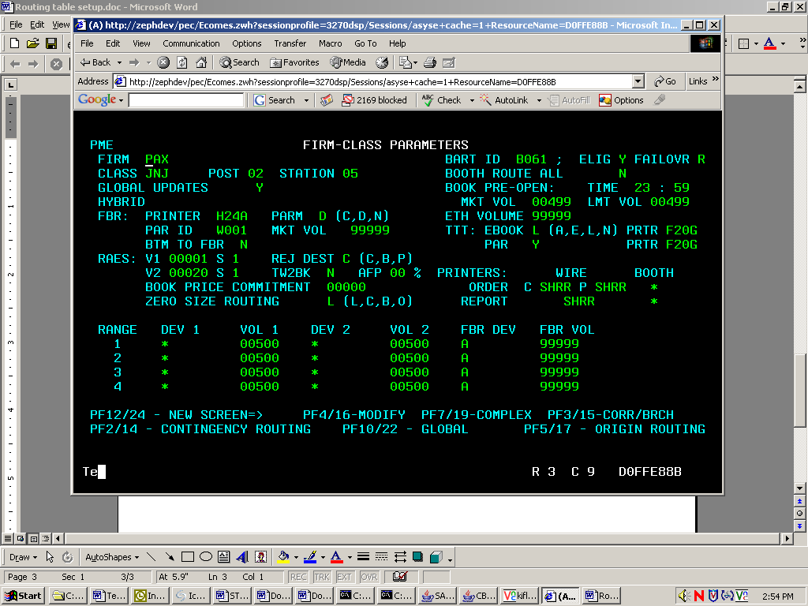

(F2)Contingency Routing Table Setup

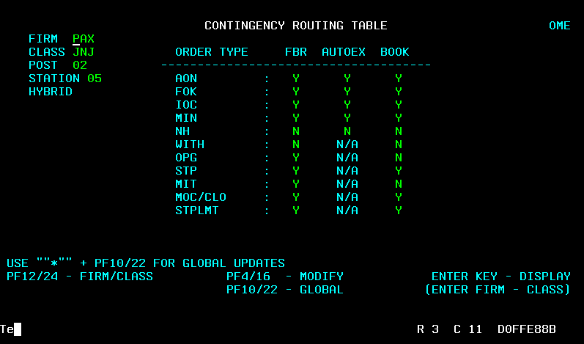
(F5) Simple Order Origin Routing Setup

- Set the ‘C’ Origin type to route directly to PAR
- Set the ‘D’ Origin type to route directly to PAR
- Set the ‘F’ Origin type to route directly to PAR

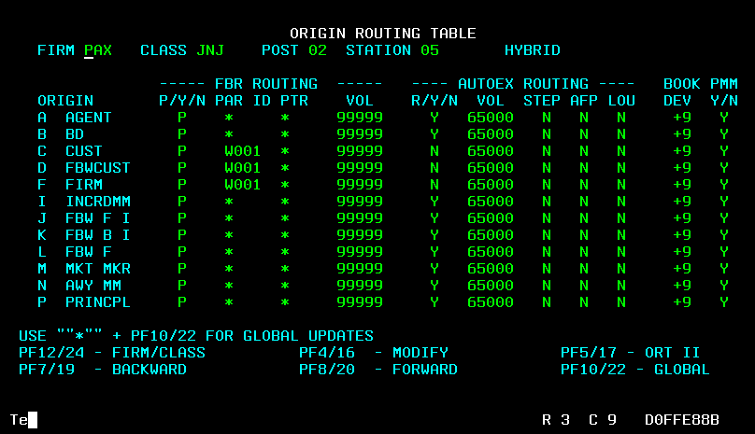

(F5 again) Order Origin Routing Setup (HAL)
- Set the ‘D’ Origin type for HAL

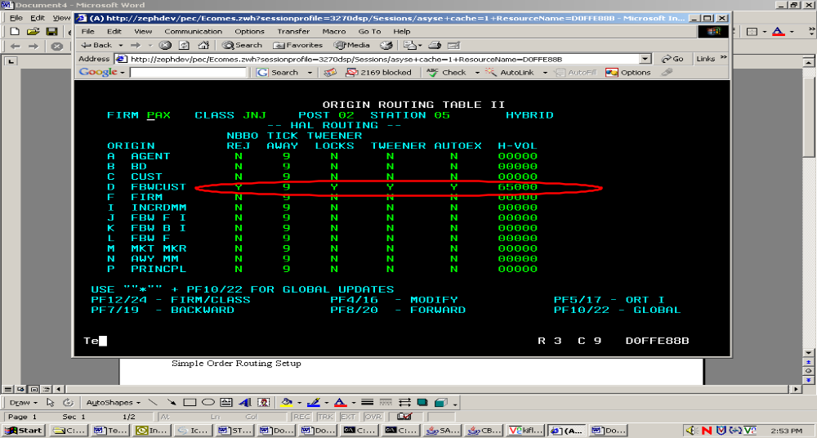
(F7) Complex Order Origin Routing Setup
- Set the ‘C’ Origin type to route directly to PAR
- Set the ‘F’ Origin type to route directly to PAR

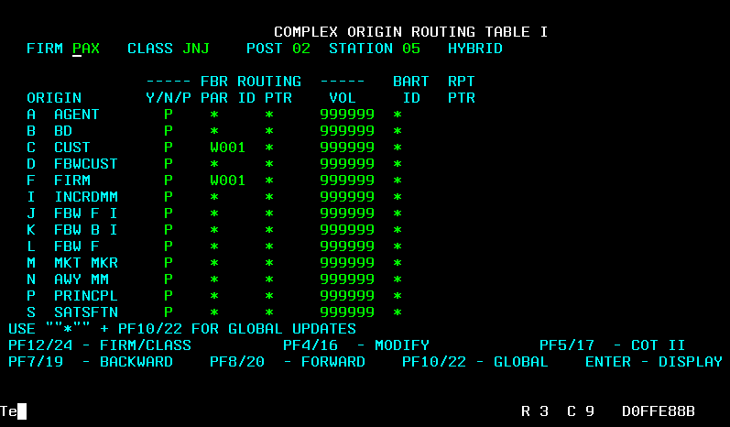

(F7 again) Complex Order Origin Routing Setup
- Set the ‘F’ Origin type for Auction

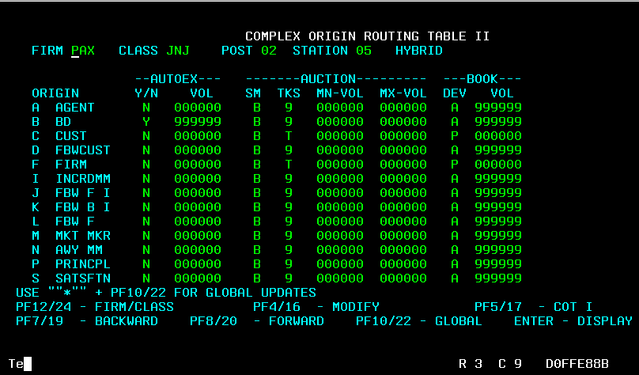

Menu 6 Table Setup
- Make sure the PAR ID matches your par station

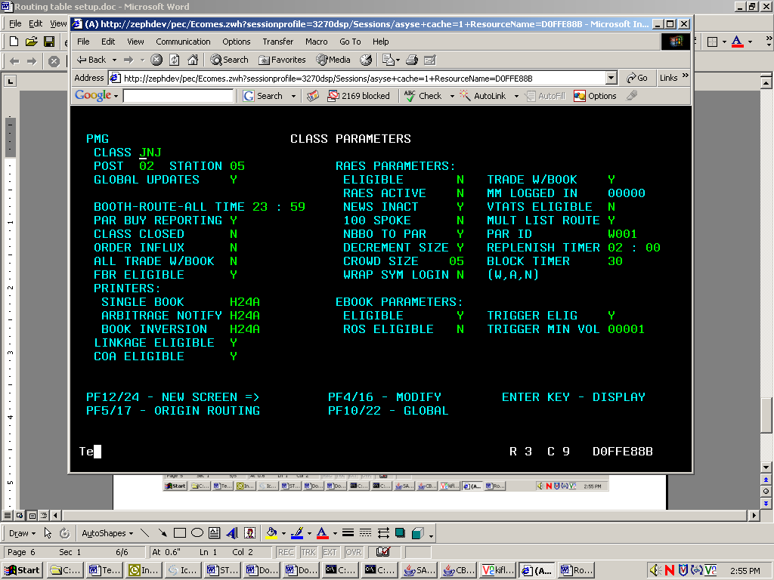

(F5) Class Origin Routing Table Setup
- Set the ‘C’ Origin type to route directly to PAR
- Set the ‘D’ Origin type to route directly to PAR
- Set the ‘F’ Origin type to route directly to PAR

